REQUEST:

1. CERTIFICATE OF NO PENDING CASE
2. Kindly reflect the middle name in full

🡪 **DONE**

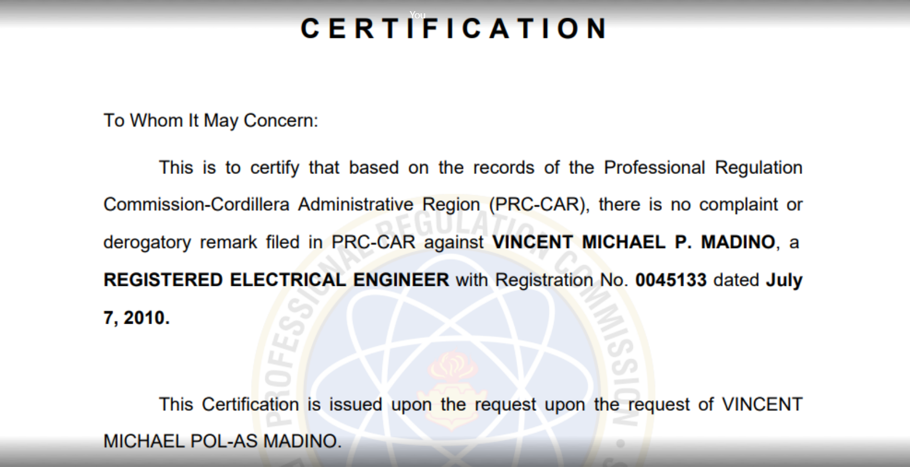

🡪 **DONE**

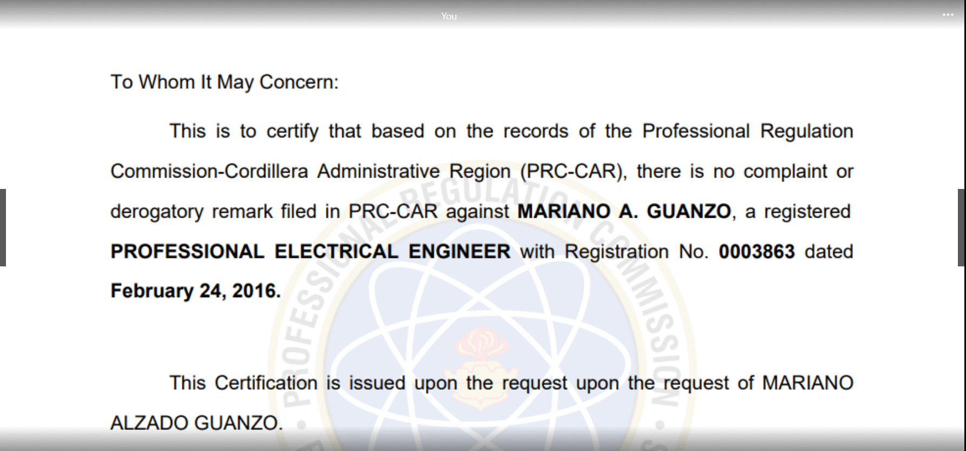

1. Please change the title to Certificate of No Pending Case or drop the word COMPLAINTS

🡪 **DONE**

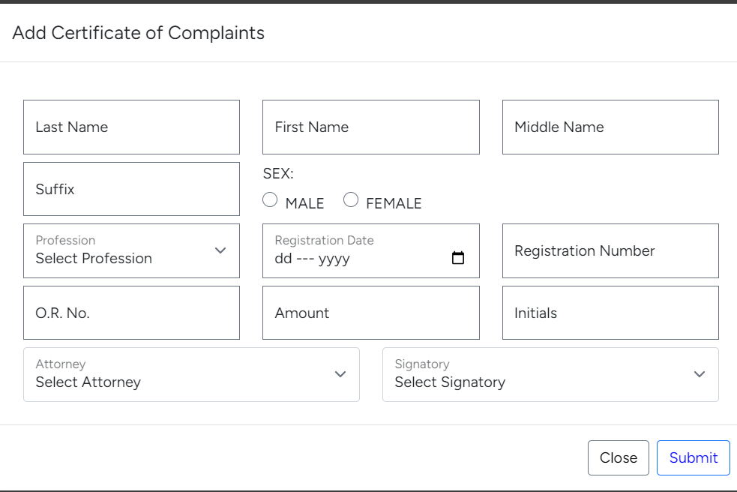

🡪 **DONE**

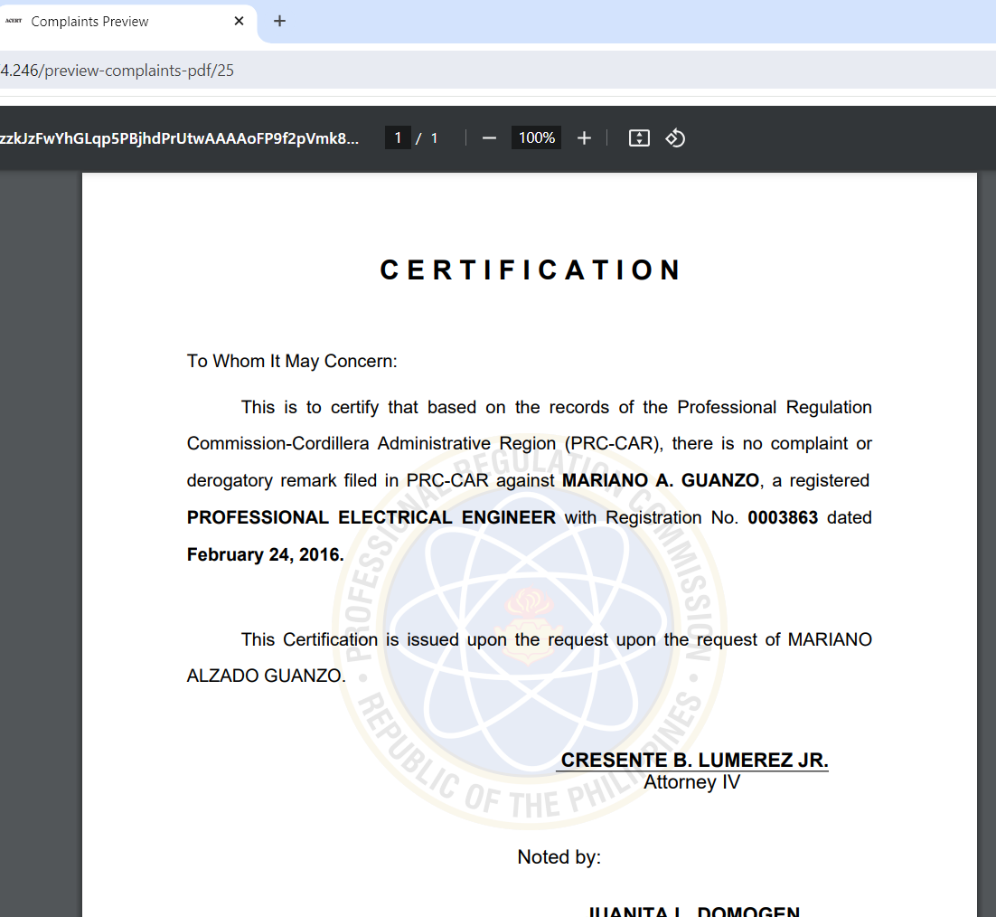

1. CERTIFICATE OF RETURNED DOCUMENTS
2. Please make the format of signatory the same with the format with the cert. of no pending case (Name and designation; drop the Hearing Officer)

🡪 **DONE**

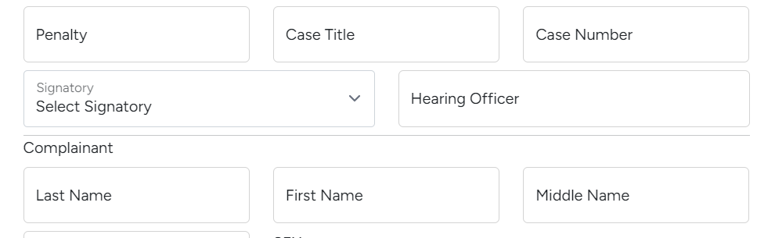



1. CERTIFICATE OF DOCUMENT SURRENDERED

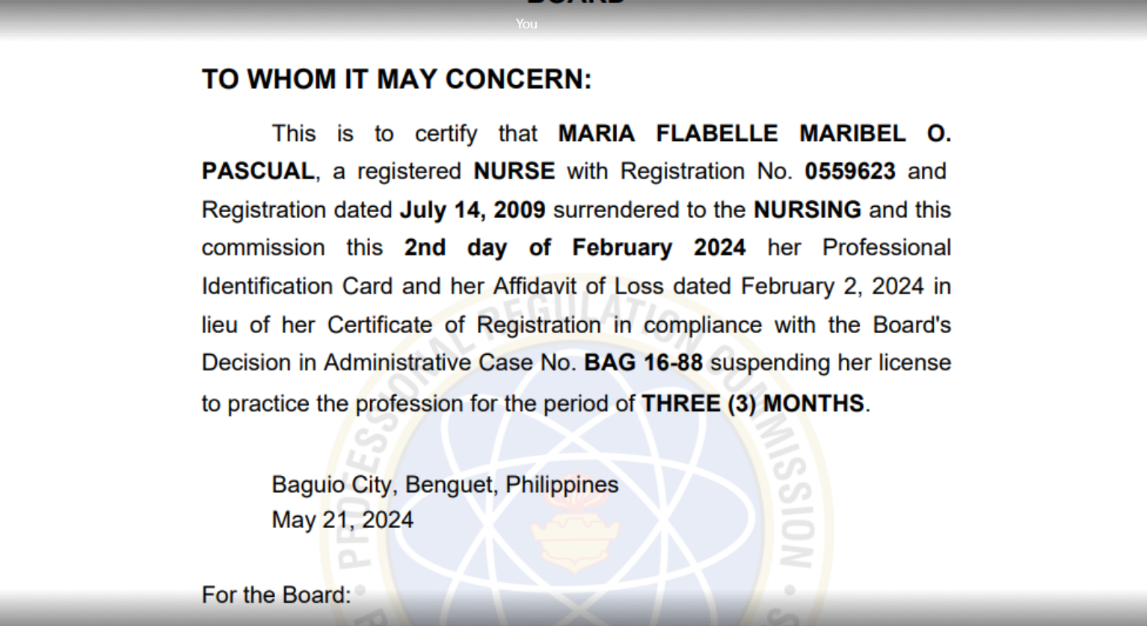

1. First oval: Please include…surrendered to the "Board of" NURSING -> **DONE**
2. Second Oval: commission in proper format 🡪 “Commission” -> **DONE**
3. Please edit the input box having this 

Since Affidavit of Loss is not always applicable; A client may surrender her PIC and COR or Affidavit of Loss in lieu of his/her PRC ID 🡪 **DONE**

1. Same with above request (Letter B, No. 1), please make the format of signatory the same with the format with the cert. of no pending case (Name and designation; drop the Hearing Officer) -> **DONE**
2. Certificate of Finality
3. Trying to fill-out this certificate, upon clicking the submit button, this displayed:

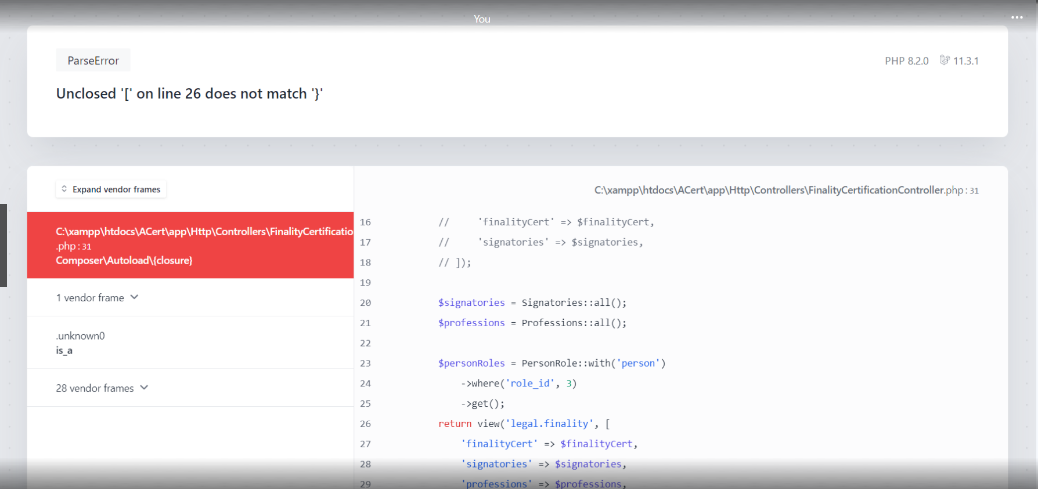

THANK YOU!!!!!